Data Visualisation Tools and Techniques

Ex1: Sales and Profit more than 10000

Output:

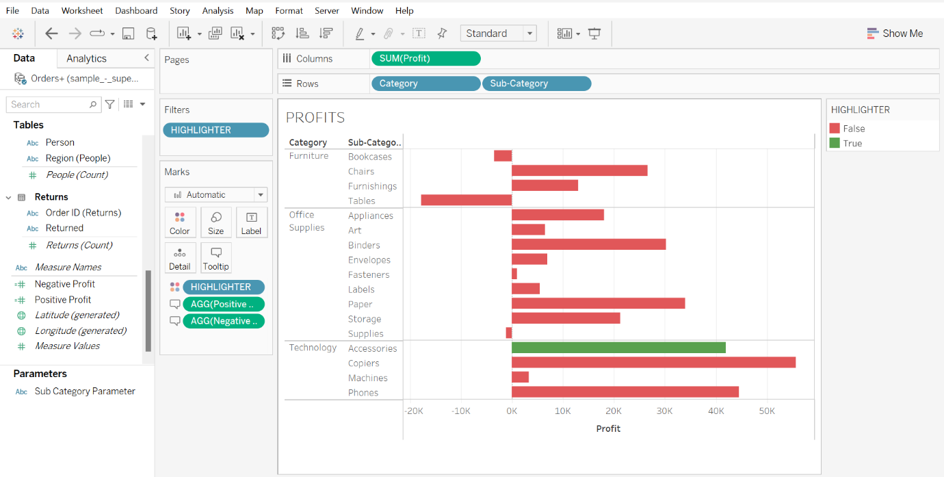

Ex2: Order Date and Category

Output:

